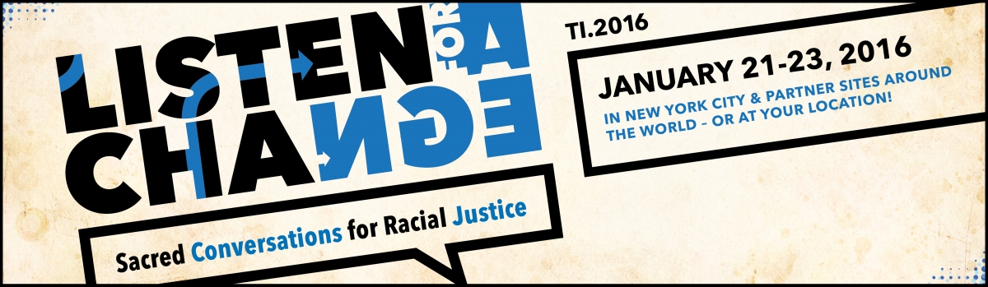

Trinity Institute Conference 2016 Registration
St. Paul’s Episcopal Church, Lansing, MI 48933

Name:______________________________________________
Email Address:________________________________________
Phone Number:____________________

Cost per day is $15.00 or $30.00 for both days.
Day(s) attending:
Friday, January 22nd:________ 9:00 am – 5:00 pm
Saturday, January 23rd:_______ 9:00 am – 5:00 pm
Both Friday and Saturday, January 22nd and 23rd:_______

Make checks payable to St. Paul’s Episcopal Church.

